EXERCISE 1: CONTROL STRUCTURES
Scenario 1: Apply 1% discount to loan interest rates for customers above 60
BEGIN
FOR rec IN (SELECT c.CustomerID, l.LoanID, l.InterestRate,
TRUNC(MONTHS_BETWEEN(SYSDATE, c.DOB) / 12) AS Age
FROM Customers c
JOIN Loans l ON c.CustomerID = l.CustomerID)
LOOP
IF rec.Age > 60 THEN
UPDATE Loans
SET InterestRate = InterestRate * 0.99
WHERE LoanID = rec.LoanID;
DBMS_OUTPUT.PUT_LINE('Discount applied to LoanID: ' || rec.LoanID
|| ' for CustomerID: ' || rec.CustomerID);
END IF;
END LOOP;
COMMIT;
END;
/
Scenario 2: Flag customers with balance over $10,000 as VIP
BEGIN
FOR rec IN (SELECT CustomerID, Name, Balance FROM Customers)
LOOP
IF rec.Balance > 10000 THEN
DBMS_OUTPUT.PUT_LINE('CustomerID: ' || rec.CustomerID
|| ' - ' || rec.Name || ' is VIP');
ELSE
DBMS_OUTPUT.PUT_LINE('CustomerID: ' || rec.CustomerID
|| ' - ' || rec.Name || ' is Regular');
END IF;
END LOOP;
END;
/
Scenario 3: Send reminders for loans due within the next 30 days
BEGIN
FOR rec IN (
SELECT l.LoanID, c.Name, l.EndDate
FROM Loans l
JOIN Customers c ON l.CustomerID = c.CustomerID
WHERE l.EndDate BETWEEN SYSDATE AND SYSDATE + 30
)
LOOP
DBMS_OUTPUT.PUT_LINE('Reminder: Dear ' || rec.Name
|| ', your loan (LoanID: ' || rec.LoanID
|| ') is due on ' || TO_CHAR(rec.EndDate,'YYYY-MM-DD'));
END LOOP;
END;
/
OUTPUT:
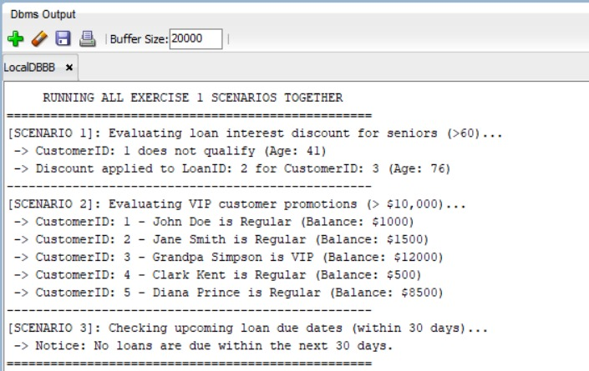

EXERCISE 2: ERROR HANDLING
Scenario 1: SafeTransferFunds – transfer between accounts with error handling
CREATE OR REPLACE PROCEDURE SafeTransferFunds(
p_from_account IN NUMBER,
p_to_account IN NUMBER,
p_amount IN NUMBER
) IS
v_balance NUMBER;
BEGIN
SELECT Balance INTO v_balance
FROM Accounts
WHERE AccountID = p_from_account
FOR UPDATE;

IF v_balance < p_amount THEN
RAISE_APPLICATION_ERROR(-20001, 'Insufficient funds in account ' || p_from_account);
END IF;

UPDATE Accounts SET Balance = Balance - p_amount WHERE AccountID = p_from_account;
UPDATE Accounts SET Balance = Balance + p_amount WHERE AccountID = p_to_account;
COMMIT;
DBMS_OUTPUT.PUT_LINE('Transfer of ' || p_amount || ' successful.');
EXCEPTION
WHEN OTHERS THEN
ROLLBACK;
DBMS_OUTPUT.PUT_LINE('Error: ' || SQLERRM);
END;
/

Scenario 2: UpdateSalary – update employee salary with error handling
CREATE OR REPLACE PROCEDURE UpdateSalary(
p_employee_id IN NUMBER,
p_percentage IN NUMBER
) IS
v_count NUMBER;
BEGIN
SELECT COUNT(*) INTO v_count FROM Employees WHERE EmployeeID = p_employee_id;

IF v_count = 0 THEN
RAISE_APPLICATION_ERROR(-20002, 'Employee ID ' || p_employee_id || ' does not exist.');
END IF;

UPDATE Employees
SET Salary = Salary + (Salary * p_percentage / 100)
WHERE EmployeeID = p_employee_id;

COMMIT;
DBMS_OUTPUT.PUT_LINE('Salary updated successfully for EmployeeID: ' || p_employee_id);
EXCEPTION
WHEN OTHERS THEN
ROLLBACK;
DBMS_OUTPUT.PUT_LINE('Error: ' || SQLERRM);
END;
/

Scenario 3: AddNewCustomer – insert customer, prevent duplicate CustomerID
CREATE OR REPLACE PROCEDURE AddNewCustomer(
p_customer_id IN NUMBER,
p_name IN VARCHAR2,
p_dob IN DATE,
p_balance IN NUMBER
) IS
v_count NUMBER;
BEGIN
SELECT COUNT(*) INTO v_count FROM Customers WHERE CustomerID = p_customer_id;

IF v_count > 0 THEN
RAISE_APPLICATION_ERROR(-20003, 'Customer ID ' || p_customer_id || ' already exists.');
END IF;

INSERT INTO Customers (CustomerID, Name, DOB, Balance, LastModified)
VALUES (p_customer_id, p_name, p_dob, p_balance, SYSDATE);

COMMIT;
DBMS_OUTPUT.PUT_LINE('Customer added successfully.');
EXCEPTION
WHEN OTHERS THEN
ROLLBACK;
DBMS_OUTPUT.PUT_LINE('Error: ' || SQLERRM);
END;
/
OUTPUT:
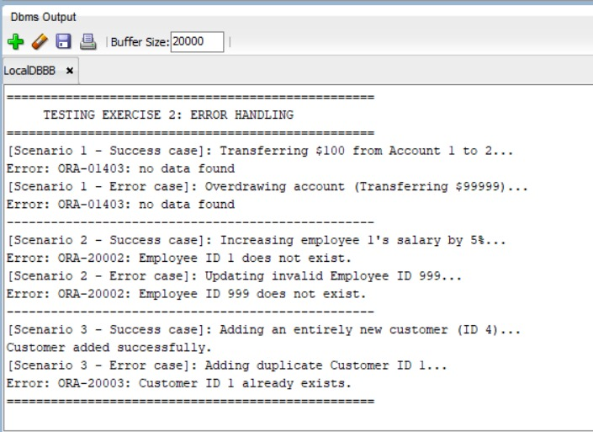
EXERCISE 3: STORED PROCEDURES

Scenario 1: ProcessMonthlyInterest – apply 1% interest to all savings accounts
CREATE OR REPLACE PROCEDURE ProcessMonthlyInterest IS
BEGIN
UPDATE Accounts
SET Balance = Balance + (Balance * 0.01),
LastModified = SYSDATE
WHERE AccountType = 'Savings';

COMMIT;
DBMS_OUTPUT.PUT_LINE(SQL%ROWCOUNT || ' savings account(s) updated with monthly interest.');
END;
/

Scenario 2: UpdateEmployeeBonus – add bonus percentage to a department's salaries
CREATE OR REPLACE PROCEDURE UpdateEmployeeBonus(
p_department IN VARCHAR2,
p_bonus_percent IN NUMBER
) IS
BEGIN
UPDATE Employees
SET Salary = Salary + (Salary * p_bonus_percent / 100)
WHERE Department = p_department;

COMMIT;
DBMS_OUTPUT.PUT_LINE(SQL%ROWCOUNT || ' employee(s) in ' || p_department || ' updated.');
END;
/

Scenario 3: TransferFunds – transfer with balance check
CREATE OR REPLACE PROCEDURE TransferFunds(
p_from_account IN NUMBER,
p_to_account IN NUMBER,
p_amount IN NUMBER
) IS
v_balance NUMBER;
BEGIN
SELECT Balance INTO v_balance
FROM Accounts
WHERE AccountID = p_from_account;

IF v_balance < p_amount THEN
RAISE_APPLICATION_ERROR(-20004, 'Insufficient balance for transfer.');
END IF;

UPDATE Accounts SET Balance = Balance - p_amount WHERE AccountID = p_from_account;
UPDATE Accounts SET Balance = Balance + p_amount WHERE AccountID = p_to_account;
COMMIT;
DBMS_OUTPUT.PUT_LINE('Transfer completed successfully.');
EXCEPTION
WHEN OTHERS THEN
ROLLBACK;
DBMS_OUTPUT.PUT_LINE('Transfer failed: ' || SQLERRM);
END;
/

OUTPUT:
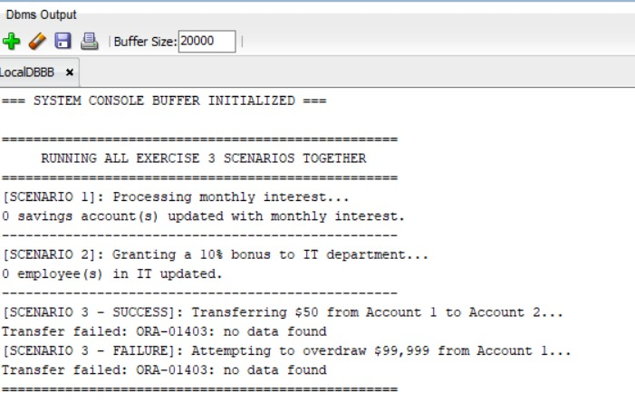

EXERCISE 4: FUNCTIONS

Scenario 1: CalculateAge – returns age in years from date of birth
CREATE OR REPLACE FUNCTION CalculateAge(p_dob IN DATE)
RETURN NUMBER IS
BEGIN
RETURN TRUNC(MONTHS_BETWEEN(SYSDATE, p_dob) / 12);
END;
/

-Scenario 2: CalculateMonthlyInstallment – EMI calculation
CREATE OR REPLACE FUNCTION CalculateMonthlyInstallment(
p_loan_amount IN NUMBER,
p_interest_rate IN NUMBER, -- annual rate in %
p_duration_years IN NUMBER
) RETURN NUMBER IS
v_monthly_rate NUMBER;
v_months NUMBER;
v_emi NUMBER;
BEGIN
v_monthly_rate := p_interest_rate / (12 * 100);
v_months := p_duration_years * 12;

IF v_monthly_rate = 0 THEN
v_emi := p_loan_amount / v_months;
ELSE
v_emi := p_loan_amount
* (v_monthly_rate * POWER(1 + v_monthly_rate, v_months))
/ (POWER(1 + v_monthly_rate, v_months) - 1);
END IF;

RETURN ROUND(v_emi, 2);
END;
/

-Scenario 3: HasSufficientBalance – checks if account balance >= amount
CREATE OR REPLACE FUNCTION HasSufficientBalance(
p_account_id IN NUMBER,
p_amount IN NUMBER
) RETURN BOOLEAN IS
v_balance NUMBER;
BEGIN
SELECT Balance INTO v_balance
FROM Accounts
WHERE AccountID = p_account_id;

RETURN v_balance >= p_amount;
EXCEPTION
WHEN NO_DATA_FOUND THEN
RETURN FALSE;
END;
/
OUTPUT:
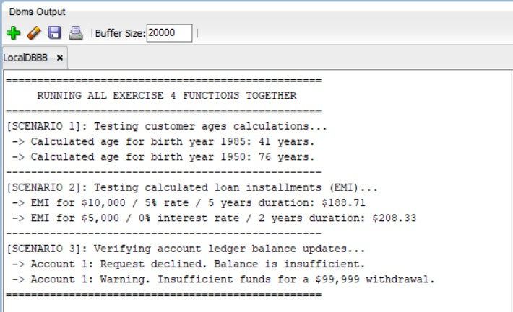

EXERCISE 5: TRIGGERS

Scenario 1: UpdateCustomerLastModified – update LastModified on row update
CREATE OR REPLACE TRIGGER UpdateCustomerLastModified
BEFORE UPDATE ON Customers
FOR EACH ROW
BEGIN
:NEW.LastModified := SYSDATE;
END;
/

Scenario 2: LogTransaction – insert audit record on new transaction
CREATE OR REPLACE TRIGGER LogTransaction
AFTER INSERT ON Transactions
FOR EACH ROW
BEGIN
INSERT INTO AuditLog (AuditID, AccountID, Amount, TransactionType, LogDate)
VALUES (audit_seq.NEXTVAL, :NEW.AccountID, :NEW.Amount, :NEW.TransactionType, SYSDATE);
END;
/

Scenario 3: CheckTransactionRules – enforce business rules on deposits/withdrawals
CREATE OR REPLACE TRIGGER CheckTransactionRules
BEFORE INSERT ON Transactions
FOR EACH ROW
DECLARE
v_balance NUMBER;
BEGIN
SELECT Balance INTO v_balance
FROM Accounts
WHERE AccountID = :NEW.AccountID;

IF :NEW.TransactionType = 'Withdrawal' AND v_balance < :NEW.Amount THEN
RAISE_APPLICATION_ERROR(-20005,
'Withdrawal denied: Insufficient balance in AccountID ' || :NEW.AccountID);
END IF;

IF :NEW.TransactionType = 'Deposit' AND :NEW.Amount <= 0 THEN
RAISE_APPLICATION_ERROR(-20006,
'Deposit amount must be positive.');
END IF;
END;
/
OUTPUT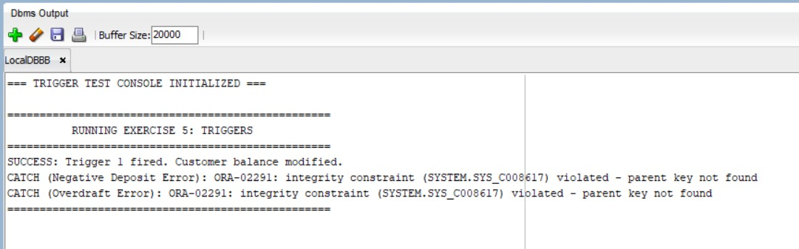

EXERCISE 6: CURSORS
Scenario 1: GenerateMonthlyStatements – print all transactions for current month
DECLARE
CURSOR GenerateMonthlyStatements IS
SELECT c.CustomerID, c.Name, t.TransactionDate, t.Amount, t.TransactionType
FROM Customers c
JOIN Accounts a ON c.CustomerID = a.CustomerID
JOIN Transactions t ON a.AccountID = t.AccountID
WHERE TRUNC(t.TransactionDate,'MM') = TRUNC(SYSDATE,'MM')
ORDER BY c.CustomerID, t.TransactionDate;
BEGIN
FOR rec IN GenerateMonthlyStatements LOOP
DBMS_OUTPUT.PUT_LINE(
'Customer: ' || rec.Name ||
' | Date: ' || TO_CHAR(rec.TransactionDate,'YYYY-MM-DD') ||
' | Type: ' || rec.TransactionType ||
' | Amount: ' || rec.Amount
);
END LOOP;
END;
/

Scenario 2: ApplyAnnualFee – deduct annual maintenance fee from all accounts
DECLARE
CURSOR ApplyAnnualFee IS
SELECT AccountID, Balance FROM Accounts FOR UPDATE;
v_fee CONSTANT NUMBER := 50; -- annual fee amount
BEGIN
FOR rec IN ApplyAnnualFee LOOP
UPDATE Accounts
SET Balance = Balance - v_fee,
LastModified = SYSDATE
WHERE CURRENT OF ApplyAnnualFee;

DBMS_OUTPUT.PUT_LINE('Annual fee deducted for AccountID: ' || rec.AccountID);
END LOOP;
COMMIT;
END;
/

Scenario 3: UpdateLoanInterestRates – update rates based on new policy
DECLARE
CURSOR UpdateLoanInterestRates IS
SELECT LoanID, InterestRate FROM Loans FOR UPDATE;
v_new_rate NUMBER;
BEGIN
FOR rec IN UpdateLoanInterestRates LOOP
-- New policy: add 0.5% to existing rate
v_new_rate := rec.InterestRate + 0.5;

UPDATE Loans
SET InterestRate = v_new_rate
WHERE CURRENT OF UpdateLoanInterestRates;

DBMS_OUTPUT.PUT_LINE('LoanID: ' || rec.LoanID
|| ' updated to rate: ' || v_new_rate);
END LOOP;
COMMIT;
END;
/

OUTPUT:
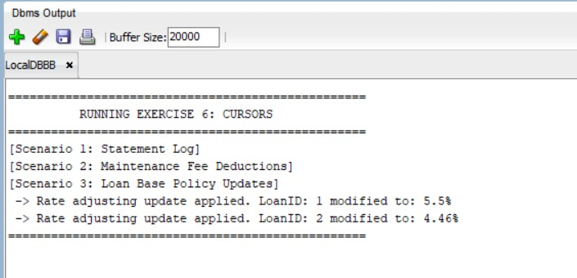
EXERCISE 7: PACKAGES
Scenario 1: CustomerManagement package
CREATE OR REPLACE PACKAGE CustomerManagement IS
PROCEDURE AddCustomer(
p_id IN NUMBER,
p_name IN VARCHAR2,
p_dob IN DATE,
p_balance IN NUMBER
);
PROCEDURE UpdateCustomerDetails(
p_id IN NUMBER,
p_name IN VARCHAR2,
p_balance IN NUMBER
);
FUNCTION GetCustomerBalance(p_id IN NUMBER) RETURN NUMBER;
END CustomerManagement;
/

CREATE OR REPLACE PACKAGE BODY CustomerManagement IS

PROCEDURE AddCustomer(
p_id IN NUMBER,
p_name IN VARCHAR2,
p_dob IN DATE,
p_balance IN NUMBER
) IS
BEGIN
INSERT INTO Customers (CustomerID, Name, DOB, Balance, LastModified)
VALUES (p_id, p_name, p_dob, p_balance, SYSDATE);
COMMIT;
DBMS_OUTPUT.PUT_LINE('Customer ' || p_name || ' added.');
EXCEPTION
WHEN DUP_VAL_ON_INDEX THEN
DBMS_OUTPUT.PUT_LINE('Error: Customer ID ' || p_id || ' already exists.');
END AddCustomer;

PROCEDURE UpdateCustomerDetails(
p_id IN NUMBER,
p_name IN VARCHAR2,
p_balance IN NUMBER
) IS
BEGIN
UPDATE Customers
SET Name = p_name, Balance = p_balance, LastModified = SYSDATE
WHERE CustomerID = p_id;
COMMIT;
DBMS_OUTPUT.PUT_LINE('Customer ' || p_id || ' updated.');
END UpdateCustomerDetails;

FUNCTION GetCustomerBalance(p_id IN NUMBER) RETURN NUMBER IS
v_balance NUMBER;
BEGIN
SELECT Balance INTO v_balance FROM Customers WHERE CustomerID = p_id;
RETURN v_balance;
EXCEPTION
WHEN NO_DATA_FOUND THEN
RETURN NULL;
END GetCustomerBalance;

END CustomerManagement;
/
OUTPUT:
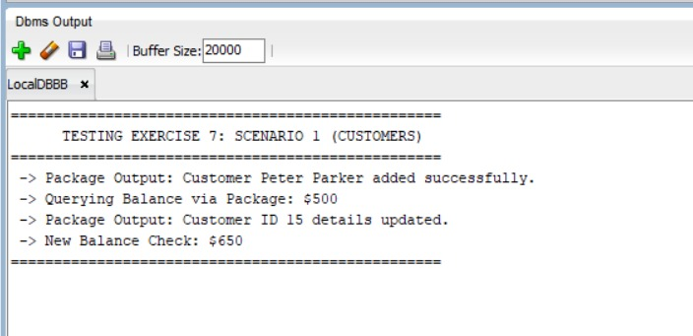

Scenario 2: EmployeeManagement package
CREATE OR REPLACE PACKAGE EmployeeManagement IS
PROCEDURE HireEmployee(
p_id IN NUMBER,
p_name IN VARCHAR2,
p_position IN VARCHAR2,
p_salary IN NUMBER,
p_department IN VARCHAR2,
p_hiredate IN DATE
);
PROCEDURE UpdateEmployeeDetails(
p_id IN NUMBER,
p_position IN VARCHAR2,
p_salary IN NUMBER
);
FUNCTION CalculateAnnualSalary(p_id IN NUMBER) RETURN NUMBER;
END EmployeeManagement;
/

CREATE OR REPLACE PACKAGE BODY EmployeeManagement IS

PROCEDURE HireEmployee(
p_id IN NUMBER,
p_name IN VARCHAR2,
p_position IN VARCHAR2,
p_salary IN NUMBER,
p_department IN VARCHAR2,
p_hiredate IN DATE
) IS
BEGIN
INSERT INTO Employees (EmployeeID, Name, Position, Salary, Department, HireDate)
VALUES (p_id, p_name, p_position, p_salary, p_department, p_hiredate);
COMMIT;
DBMS_OUTPUT.PUT_LINE('Employee ' || p_name || ' hired.');
END HireEmployee;

PROCEDURE UpdateEmployeeDetails(
p_id IN NUMBER,
p_position IN VARCHAR2,
p_salary IN NUMBER
) IS
BEGIN
UPDATE Employees
SET Position = p_position, Salary = p_salary
WHERE EmployeeID = p_id;
COMMIT;
DBMS_OUTPUT.PUT_LINE('Employee ' || p_id || ' details updated.');
END UpdateEmployeeDetails;

FUNCTION CalculateAnnualSalary(p_id IN NUMBER) RETURN NUMBER IS
v_monthly NUMBER;
BEGIN
SELECT Salary INTO v_monthly FROM Employees WHERE EmployeeID = p_id;
RETURN v_monthly * 12;
EXCEPTION
WHEN NO_DATA_FOUND THEN
RETURN NULL;
END CalculateAnnualSalary;

END EmployeeManagement;
/
OUTPUT:
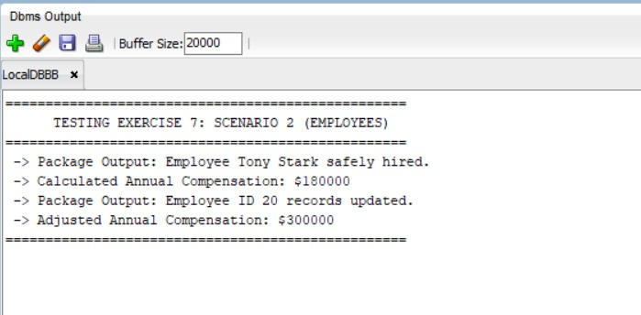

Scenario 3: AccountOperations package
CREATE OR REPLACE PACKAGE AccountOperations IS
PROCEDURE OpenAccount(
p_account_id IN NUMBER,
p_customer_id IN NUMBER,
p_account_type IN VARCHAR2,
p_balance IN NUMBER
);
PROCEDURE CloseAccount(p_account_id IN NUMBER);
FUNCTION GetTotalBalance(p_customer_id IN NUMBER) RETURN NUMBER;
END AccountOperations;
/

CREATE OR REPLACE PACKAGE BODY AccountOperations IS

PROCEDURE OpenAccount(
p_account_id IN NUMBER,
p_customer_id IN NUMBER,
p_account_type IN VARCHAR2,
p_balance IN NUMBER
) IS
BEGIN
INSERT INTO Accounts (AccountID, CustomerID, AccountType, Balance, LastModified)
VALUES (p_account_id, p_customer_id, p_account_type, p_balance, SYSDATE);
COMMIT;
DBMS_OUTPUT.PUT_LINE('Account ' || p_account_id || ' opened for CustomerID: ' || p_customer_id);
END OpenAccount;

PROCEDURE CloseAccount(p_account_id IN NUMBER) IS
BEGIN
DELETE FROM Accounts WHERE AccountID = p_account_id;
COMMIT;
DBMS_OUTPUT.PUT_LINE('Account ' || p_account_id || ' closed.');
END CloseAccount;

FUNCTION GetTotalBalance(p_customer_id IN NUMBER) RETURN NUMBER IS
v_total NUMBER;
BEGIN
SELECT NVL(SUM(Balance), 0)
INTO v_total
FROM Accounts
WHERE CustomerID = p_customer_id;
RETURN v_total;
END GetTotalBalance;

END AccountOperations;
/
OUTPUT:
